ASP.NET Architecture
ASP.NET Web Applications ASP.NET Web Application Security

This section provides an overview of the ASP.NET infrastructure and subsystemrelationships, as they relate to the subject of security. The following illustration shows the relationships among the security systems in ASP.NET.
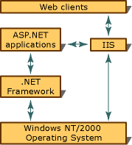
As the illustration shows, all Web clients communicate with ASP.NET applications through IIS. IIS deciphers and optionally authenticates the request. If Allow Anonymous is turned on, no authentication occurs. IIS also finds the requested resource ( such as an ASP.NET application ), and, if the client is authorized, returns the appropriate resource.
In addition to the built-in ASP.NET security features, an ASP.NET application can use the low-level security features of the .NET Framework. For more information, see Key Security Concepts.

Integrating with IIS
This release of ASP.NET uses IIS 5.0 as the primary host environment. When considering ASP.NET authentication, you should understand the interaction with IIS authentication services.
IIS always assumes that a set of credentials maps to a Windows NT account and uses them to authenticate a user. There are three different kinds of authentication available in IIS 5.0: basic, digest, and Integrated Windows Authentication ( NTLM or Kerberos ). You can select the type of authentication to use in the IIS administrative services. For more information on IIS authentication, see the IIS documentation.
If you request a URL containing an ASP.NET application, the request and authentication information are handed off to the application. ASP.NET provides the two additional types of authentication described in the following table.
ASP.NET authentication provider | Description
Forms authentication | A system by which unauthenticated requests are redirected to an HTML form using HTTP client-side redirection. The user provides credentials and submits the form. If the application authenticates the request, the system issues a form that contains the credentials or a key for reacquiring the identity. Subsequent requests are issued with the form in the request headers; they are authenticated and authorized by an ASP.NET handler using whatever validation method the application developer specifies.
Passport authentication | Centralized authentication service provided by Microsoft that offers a single log on and core profile services for member sites.

Using ASP.NET Configuration Files
ASP.NET configuration, of which security is a part, has a hierarchical architecture. All configuration information for ASP.NET is contained in files named Web.config and Machine.config. Web.config can be placed in the same directories as the application files. The Machine.config file is in the Config directory of the install root. Subdirectories inherit a directory's settings unless overridden by a Web.config file in the subdirectory. In a Web.config file, there are sections for each major category of ASP.NET functionality. To see an example of the way in which the hierarchical configuration system works for security see Hierarchical Configuration Architecture.
The security section of a Web.config file is organized as follows:
<authentication mode = " [ Windows/Forms/Passport/None ] ">
<forms name = " [ name ] " loginUrl = " [ url ] " >
<credentials passwordFormat = " [ Clear, SHA1, MD5 ] ">
<user name = " [ UserName ] " password = " [ password ] " />
</credentials>
</forms>
<passport redirectUrl = "internal" />
</authentication>

<authorization>
<allow users = " [ comma separated list of users ] "
roles = " [ comma separated list of roles ] " />
<deny users = " [ comma separated list of users ] "
roles = " [ comma separated list of roles ] " />
</authorization>

<identity impersonate = " [ true/false ] " />
The default settings for these elements are shown in the following table.
Default Value | Comment
<allow roles= > | No default value
<allow users = "*"> | All
<authentication mode = "Windows"> | The authentication mode cannot be set at a level below the application root directory.
<credentials passwordFormat = "SHA1"> | The hashing algorithm to be used on passwords.
<deny roles = ""> | Empty
<deny users = ""> | Empty
<forms loginUrl = "login.aspx"> | If you set the mode to forms, and if the request does not have a valid form, this is the URL to which the request is directed for a forms-based logon.
<forms name = ".ASPXAUTH"> | Forms name.
<forms path = "/"> | Path.
<forms protection = "type"> | Type= [ All|None|Encryption|Validation ]
<forms timeout = "30"> | Timeout in seconds.
<forms validation = "?"> | True or false.
<identity impersonate = "false"> | Impersonation is disabled by default.
<passport redirectUrl = "internal" | If you set the mode to passport, and if the requested page requires authentication but the user has not logged on with Passport, then the user will be redirected to this URL.
<user name = ""> | Empty
<user password = ""> | Empty
There are three major subsections: authentication, authorization, and identity. The values for each of the elements are usually set by overriding this section of the computer-level configuration file with a similar section in an application configuration file placed in the application root. All subdirectories automatically inherit those settings. However, subdirectories can have their own configuration files that override other settings.
NOTE: ASP.NET configuration only applies to ASP.NET resources ( those registered to be handled by Aspnet_isapi.dll ). Unfortunately, ASP.NET configuration cannot provide authorization for non-Aspnet_isapi.dll resources, so TXT, HTML, GIF, JPEG, ASP, and other types of files are still accessible by all users, subject to IIS permissions. For example, even though the ASP.NET resources in a directory might be restricted by a Web.config file, all users can still view the files located in that directory if directory browsing is on and no other restrictions are in place.
You can avoid this situation by explicitly mapping such files, but not directories, to Aspnet_isapi.dll using the IIS administration tool. However, there could be a performance impact if you do this.
You can use the <location></location> tags to specify a particular file or directory to which settings should apply. For more information about how to use the <location> tag, see Hierarchical Configuration Architecture and Configuration <location> Settings.
For more details about ASP.NET configuration in general, see ASP.NET Configuration. The topics that follow provide the data flow details that show how security is handled by ASP.NET, and how the data flows through the security subsystems.

ASP.NET application and page life cycle

1 vote(s)
Rating: 5 out of 5

Posted on: 4/17/2010 5:48:10 PM by Questpond | Views: 10527 | Category: ASP.NET MVC | Level: Beginner

In this article we will try to understand what are the different events which takes place right from the time the user sends a request, until the time request is rendered on the browser. So we will first try to understand the two broader steps of an ASP.NET request and then we will move in to different events emitted from ‘HttpHandler’, ‘HttpModule’ and ASP.NET page object. As we move in this event journey we will try to understand what kind of logic should go in each every of these events.

Download
Download source code for ASP.NET application and page life cycle
Buy proven .NET Trainings on www.ITFunda.Com (Adv)
Introduction
The Two step process
Creation of ASP.NET environment
Process request using MHPM events fired
In What event we should do what?
A sample code for demonstration
Zooming ASP.NET page events
Source code
References

Introduction
In this article we will try to understand what are the different events which takes place right from the time the user sends a request, until the time request is rendered on the browser. So we will first try to understand the two broader steps of an ASP.NET request and then we will move in to different events emitted from ‘HttpHandler’, ‘HttpModule’ and ASP.NET page object. As we move in this event journey we will try to understand what kind of logic should go in each every of these events.
This is a small Ebook for all my .NET friends which covers topics like WCF,WPF,WWF,Ajax,Core .NET,SQL etc you can download the same from http://tinyurl.com/4nvp9t or else you can catch me on my daily free training @ http://tinyurl.com/y4mbsn6

The Two step process
From 30,000 feet level ASP.NET request processing is a 2 step process as shown below. User sends a request to the IIS:-
• ASP.NET creates an environment which can process the request. In other words it creates the application object, request, response and context objects to process the request.
• Once the environment is created the request is processed through series of events which is processed by using modules, handlers and page objects. To keep it short lets name this step as MHPM (Module, handler, page and Module event), we will come to details later.
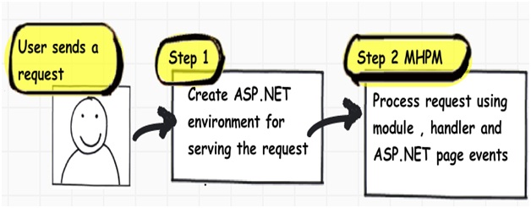
In the coming sections we will understand both these main steps in more details.

Creation of ASP.NET environment
Step 1:- The user sends a request to IIS. IIS first checks which ISAPI extension can serve this request. Depending on file extension the request is processed. For instance if the page is an ‘.ASPX page’ then it will be passed to ‘aspnet_isapi.dll’ for processing.
Step 2:- If this the first request to the website then a class called as ‘ApplicationManager’ creates an application domain where the website can run. As we all know application domain creates isolation between two web applications hosted on the same IIS. So in case there is issue in one app domain it does not affect the other app domain.
Step 3:- The newly created application domain creates hosting environment i.e. the ‘HttpRuntime’ object. Once the hosting environment is created necessary core ASP.NET objects like ‘HttpContext’ , ‘HttpRequest’ and ‘HttpResponse’ objects are created.
Step 4:- Once all the core ASP.NET objects are created ‘HttpApplication’ object is created to serve the request. In case you have a ‘global.asax’ file in your system then object of the ‘global.asax’ file will be created. Please note ‘global.asax’ file inherits from ‘HttpApplication’ class.
Note: The first time an ASP.NET page is attached to an application, a new instance of ‘HttpApplication’ is created. Said and done to maximize performance, ‘HttpApplication’ instances might be reused for multiple requests.
Step 5:- The ‘HttpApplication’ object is then assigned to the core ASP.NET objects to process the page.
Step 6:- ‘HttpApplication’ then starts processing the request by http module events , handlers and page events. It fires the MHPM event for request processing.
Note: - For more details http://msdn.microsoft.com/en-us/library/ms178473.aspx
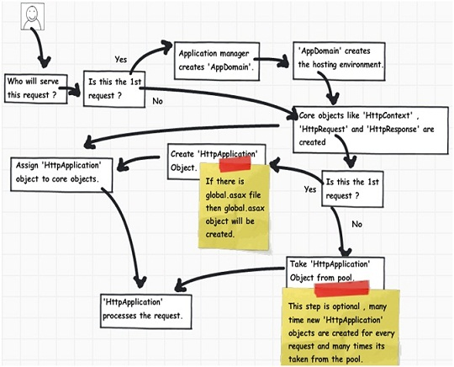
Below image explains how the internal object model looks like for an ASP.NET request. At the top level is the ASP.NET runtime which has creates an ‘Appdomain’ which in turn has ‘HttpRuntime’ with ‘request’, ‘response’ and ‘context’ objects.
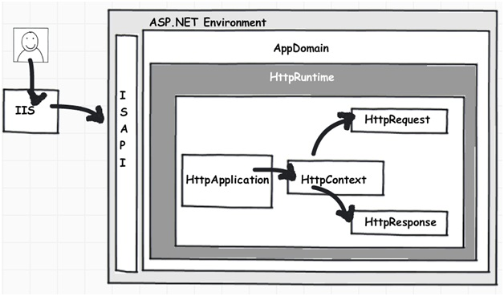

Process request using MHPM events fired
Once ‘HttpApplication’ is created it starts processing request it goes through 3 different sections ‘HttpModule’ , ‘Page’ and ‘HttpHandler’. As it moves through these sections it invokes different events which the developer can extend and add customize logic to the same.
Before we move ahead lets understand what are ‘HttpModule’ and ‘HttpHandlers’. They help us to inject custom logic before and after the ASP.NET page is processed. The main differences between both of them are:-
• If you want to inject logic based in file extensions like ‘.ASPX’ , ‘.HTML’ then you use ‘HttpHandler’. In other words ‘HttpHandler’ is an extension based processor.
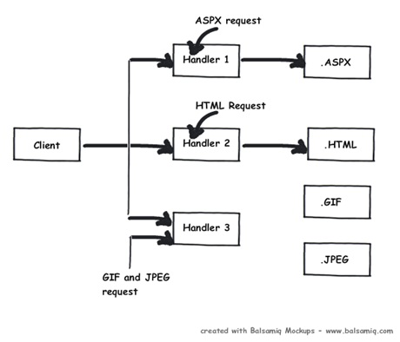
• If you want to inject logic in the events of ASP.NET pipleline then you use ‘HttpModule’. ASP.NET . In other word ‘HttpModule’ is an event based processor.
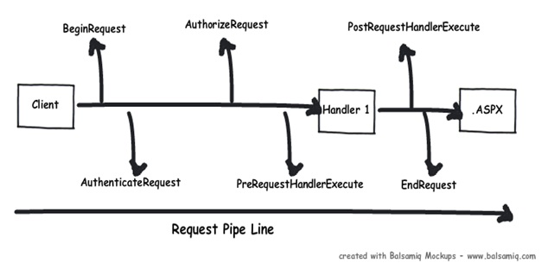
You can read more about the differences from http://computerauthor.blogspot.com/2009/09/two-interceptors-httpmodule-and.html
Below is the logical flow of how the request is processed. There are 4 important steps MHPM as explained below :-
Step 1(M ? HttpModule):- Client request processing starts. Before the ASP.NET engine goes and creates the ASP.NET ‘HttpModule’ emits events which can be used to inject customized logic. There are 6 important events which you can utilize before your page object is created ‘BeginRequest’,’AuthenticateRequest’,’AuthorizeRequest’,’ResolveRequestCache’,’AcquireRequestState’ and ‘PreRequestHandlerExecute’.
Step 2 (H ? ‘HttpHandler’ ) :- Once the above 6 events are fired , ASP.NET engine will invoke ‘ProcessRequest’ event if you have implemented ‘HttpHandler’ in your project.
Step 3 (P – ASP.NET page):- Once the ‘HttpHandler’ logic executes the ASP.NET page object is created. While the ASP.NET page object is created many events are fired which can help us to write our custom logic inside those page events. There are 6 important events which provides us placeholder to write logic inside ASP.NET pages ‘Init’ , ‘Load’ , ‘validate’ , ‘event’ , ‘render’ and ‘unload’. You can remember the word ‘SILVER’ to remember the events S – Start ( does not signify anything as such just forms the word ) , I – (Init) , L ( Load) , V ( Validate) , E ( Event) and R ( Render).
Step4 (M ? HttpModule):- Once the page object is executed and unloaded from memory ‘HttpModule’ provides post page execution events which can be used to inject custom post-processing logic. There are 4 important post-processing events ‘PostRequestHandlerExecute’, ‘ReleaserequestState’, ‘UpdateRequestCache’ and ‘EndRequest’.
Below figure shows the same in a pictorial format.
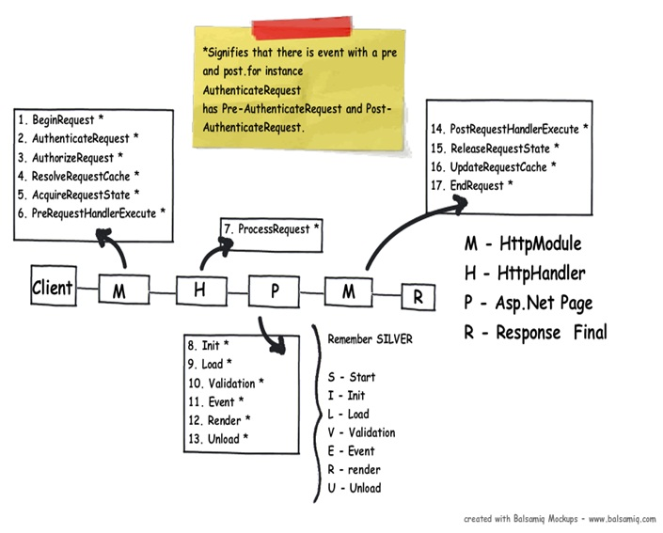

In What event we should do what?
The million dollar question is in which events we should do what? Below is the table which shows in which event what kind of logic or code can go.
Section | Event | Description
HttpModule | BeginRequest | This event signals a new request; it is guaranteed to be raised on each request.
HttpModule | AuthenticateRequest | This event signals that ASP.NET runtime is ready to authenticate the user. Any authentication code can be injected here.
HttpModule | AuthorizeRequest | This event signals that ASP.NET runtime is ready to authorize the user. Any authorization code can be injected here.
HttpModule | ResolveRequestCache | In ASP.NET we normally use outputcache directive to do caching. In this event ASP.NET runtime determines if the page can be served from the cache rather than loading the patch from scratch. Any caching specific activity can be injected here.
HttpModule | AcquireRequestState | This event signals that ASP.NET runtime is ready to acquire session variables. Any processing you would like to do on session variables.
HttpModule | PreRequestHandlerExecute | This event is raised just prior to handling control to the HttpHandler. Before you want the control to be handed over to the handler any pre-processing you would like to do.
HttpHandler | ProcessRequest | Httphandler logic is executed. In this section we will write logic which needs to be executed as per page extensions.
Page | Init | This event happens in the ASP.NET page and can be used for :-  · Creating controls dynamically, in case you have controls to be created on runtime.  · Any setting initialization.  · Master pages and them settings.  In this section we do not have access to viewstate , postedvalues and neither the controls are initialized.
Page | Load | In this section the ASP.NET controls are fully loaded and you write UI manipulation logic or any other logic over here.
Page | Validate | If you have valuators on your page, you would like to check the same here.
 | Render | It’s now time to send the output to the browser. If you would like to make some changes to the final HTML which is going out to the browser you can enter your HTML logic here.
Page | Unload | Page object is unloaded from the memory.
HttpModule | PostRequestHandlerExecute | Any logic you would like to inject after the handlers are executed.
HttpModule | ReleaserequestState | If you would like to save update some state variables like session variables.
HttpModule | UpdateRequestCache | Before you end if you want to update your cache.
HttpModule | EndRequest | This is the last stage before your output is sent to the client browser.

A sample code for demonstration
With this article we have attached a sample code which shows how the events actually fire. In this code we have created a ‘HttpModule’ and ‘Httphandler’ in this project and we have displayed a simple response write in all events , below is how the output looks like.
Below is the class for ‘HttpModule’ which tracks all event s and adds it to a global collection.
public class clsHttpModule : IHttpModule
{
......
void OnUpdateRequestCache(object sender, EventArgs a)

{
objArrayList.Add("httpModule:OnUpdateRequestCache");
}
void OnReleaseRequestState(object sender, EventArgs a)
{
objArrayList.Add("httpModule:OnReleaseRequestState");
}
void OnPostRequestHandlerExecute(object sender, EventArgs a)
{
objArrayList.Add("httpModule:OnPostRequestHandlerExecute");
}
void OnPreRequestHandlerExecute(object sender, EventArgs a)
{
objArrayList.Add("httpModule:OnPreRequestHandlerExecute");
}
void OnAcquireRequestState(object sender, EventArgs a)
{
objArrayList.Add("httpModule:OnAcquireRequestState");
}
void OnResolveRequestCache(object sender, EventArgs a)
{
objArrayList.Add("httpModule:OnResolveRequestCache");
}
void OnAuthorization(object sender, EventArgs a)
{
objArrayList.Add("httpModule:OnAuthorization");
}
void OnAuthentication(object sender, EventArgs a)
{

objArrayList.Add("httpModule:AuthenticateRequest");
}
void OnBeginrequest(object sender, EventArgs a)
{

objArrayList.Add("httpModule:BeginRequest");
}
void OnEndRequest(object sender, EventArgs a)
{
objArrayList.Add("httpModule:EndRequest");
objArrayList.Add("<hr>");
foreach (string str in objArrayList)
{
httpApp.Context.Response.Write(str + "<br>") ;
}
}
}

Below is the code snippet for ‘HttpHandler’ which tracks ‘ProcessRequest’ event.
public class clsHttpHandler : IHttpHandler
{
public void ProcessRequest(HttpContext context)

{
clsHttpModule.objArrayList.Add("HttpHandler:ProcessRequest");
context.Response.Redirect("Default.aspx");
}
}

We are also tracking all the events from the ASP.NET page.
public partial class _Default : System.Web.UI.Page
{
protected void Page_init(object sender, EventArgs e)
{

clsHttpModule.objArrayList.Add("Page:Init");
}
protected void Page_Load(object sender, EventArgs e)
{
clsHttpModule.objArrayList.Add("Page:Load");
}
public override void Validate()
{
clsHttpModule.objArrayList.Add("Page:Validate");
}
protected void Button1_Click(object sender, EventArgs e)
{
clsHttpModule.objArrayList.Add("Page:Event");
}
protected override void Render(HtmlTextWriter output)
{
clsHttpModule.objArrayList.Add("Page:Render");
base.Render(output);
}
protected void Page_Unload(object sender, EventArgs e)
{
clsHttpModule.objArrayList.Add("Page:UnLoad");
}}

Below is how the display looks like with all events as per the sequence discussed in the previous section.
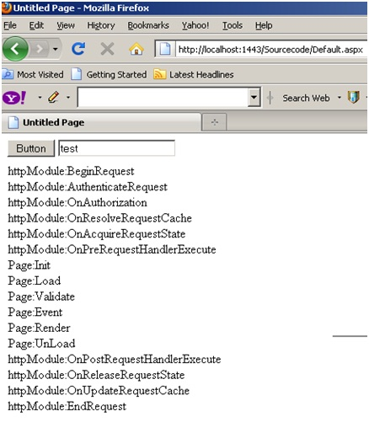

Zooming ASP.NET page events
In the above section we have seen the overall flow of events for an ASP.NET page request. One of the most important section is the ASP.NET page, we have not discussed the same in detail. So let’s take some luxury to describe the ASP.NET page events in more detail in this section.
Any ASP.NET page has 2 parts one is the page which is displayed on the browser which has HTML tags , hidden values in form of viewstate and data on the HTML inputs. When the page is posted these HTML tags are created in to ASP.NET controls with viewstate and form data tied up together on the server. Once you get these full server controls on the behind code you can execute and write your own login on the same and render the page back to the browser.
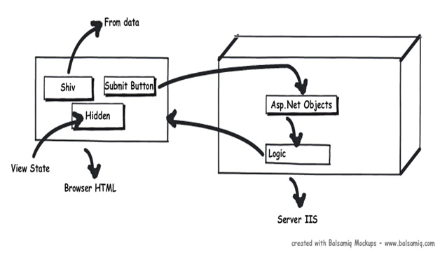
Now between these HTML controls coming live on the server as ASP.NET controls, the ASP.NET page emits out lot of events which can be consumed to inject logic. Depending on what task / logic you want to perform we need to put these logics appropriately in those events.
Note: - Most of the developers directly use the ‘page_load’ method for everything, which is not a good thought. So it’s either populating the controls, setting view state, applying themes etc everything happens on the page load. So if we can put logic in proper events as per the nature of the logic that would really make your code clean.
Seq | Events | Controls Initialized | View state  Available | Form data  Available | What Logic can be written here?
1 | Init | No | No | No | Note: - You can access form data etc by using ASP.NET request objects but not by Server controls.Creating controls dynamically, in case you have controls to be created on runtime. Any setting initialization.Master pages and them settings.In this section we do not have access to viewstate , posted values and neither the controls are initialized.
2 | Load view state | Not guaranteed | Yes | Not guaranteed | You can access view state and any synch logic where you want viewstate to be pushed to behind code variables can be done here.
3 | PostBackdata | Not guaranteed | Yes | Yes | You can access form data. Any logic where you want the form data to be pushed to behind code variables can be done here.
4 | Load | Yes | Yes | Yes | This is the place where you will put any logic you want to operate on the controls. Like flourishing a combox box from the database , sorting data on a grid etc. In this event we get access to all controls , viewstate and their posted values.
5 | Validate | Yes | Yes | Yes | If your page has validators or you want execute validation for your page this is the right place to the same.
6 | Event | Yes | Yes | Yes | If this is a post back by a button click or a dropdown change then the relative events will be fired. Any kind of logic which is related to that event can be executed here.
7 | Pre-render | Yes | Yes | Yes | If you want to make final changes to the UI objects like changing tree structure or property values, before these controls are saved in to view state.
8 | Save view state | Yes | Yes | Yes | Once all changes to server controls are done this event can be an opportunity to save control data in to view state.
9 | Render | Yes | Yes | Yes | If you want to add some custom HTML to the output this is the place you can.
10 | Unload | Yes | Yes | Yes | Any kind of clean up you would like to do here.
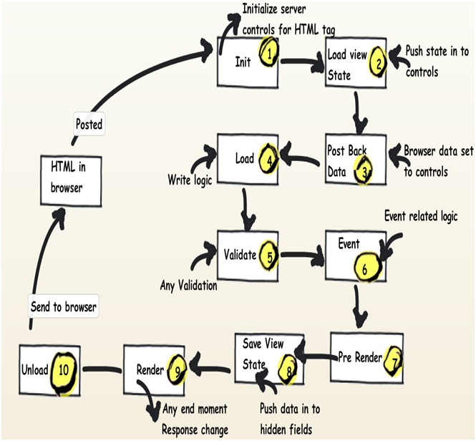
http://authors.aspalliance.com/aspxtreme/webapps/index.aspx
ASP.NET Web Applications

